1. Write a JavaScript code to find the sum of two values which are entered by the users.
2. Write a JavaScript code to find area of Circle, take radius of the circle as input form the user.
3. Write a JavaScript Program to check whether the number is Prime or Not, take input from the user.
4. Write a JavaScript code to check the Given Number is Palindrome or Not, take input from the user.
5. Write a JavaScript code for following triangle:

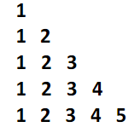

1. Write a JavaScript code to find the LCM of two numbers, take input from the user.
2. Write a Java Script program that inputs 5 even integers (for an odd integer, it should not be considered as input) from the user and prints them in non-decreasing manner.
3. Write a Java Script program that first take an integer N as inputs from the user and them take N odd integers from the user and prints them in non-decreasing manner.
4. Write a JavaScript Program that takes a string as input from the user and checks whether every character of the string is equal or not.